
Presented TO:
Unisys

Presented BY:
Everforth ECS ServiceNow Team

Overview of
Proposed
Services
Unisys – Electric Boat
ServiceNow Environment Refresh

5/21/2026
Table of Contents
1. EXECUTIVE OVERVIEW 1
2. REQUESTED ARCHITECTURE 1
2.1. PROD 1
2.2. UAT 1
2.3. DEV 2
2.4. Architectural Overview 2
3. XXXXX 2
4. ASSUMPTIONS 3
5. PRICING 3
6. PAYMENT TERMS 3
7. SUMMARY 3

EXECUTIVE OVERVIEW
Executive summary overview…

REQUESTED ARCHITECTURE
Architecture

PROD
- Expand app node hosts by two in PROD
- This places two app servers in DataCenter 1 and two app servers in DataCenter 2
- Leverage Global Server Load Balancing on F5s for app nodes
- This provides single site high availability and cross-site high availability as well by having a VIP in each data center, which manages traffic in an active/passive fashion.
- Migrate MariaDB to RaptorDB, ideally RaptorDB Professional
- This places Primary, Replica & Witness servers in DataCenter 1 and two replica servers in Data Center 2
- This provides single site high availability and cross-site high availability as well
- Leverage Global Server Load Balancing on F5s for databases
- Need automated high availability for the DBs beyond what simple replication can support. See https://support.servicenow.com/kb?id=kb_article_view&sysparm_article=KB2407699
- Need repmgr or Patroni (Distributed Configuration Store) to help support automation
- Two Predictive Intelligence Servers

UAT
- Expand app node hosts by one in UAT
- This places two app servers in DataCenter 1 and two app servers in DataCenter 2
- Leverage Global Server Load Balancing on F5s for app nodes
- This provides cross-site high availability as well by having a VIP in each data center, which manages traffic in an active/passive fashion.
- Migrate MariaDB to RaptorDB, ideally RaptorDB Professional
- This places Primary & Witness servers in DataCenter 1 and one replica server in Data Center 2
- Leverage Global Server Load Balancing on F5s for databases
- Need automated high availability for the DBs beyond what simple replication can support. See https://support.servicenow.com/kb?id=kb_article_view&sysparm_article=KB2407699
- Need repmgr or Patroni (Distributed Configuration Store) to help support automation
- Two Predictive Intelligence Servers
- Note: Make this an optional line item

DEV
- Migrate MariaDB to RaptorDB, ideally RaptorDB Professional
- This places Primary server in DataCenter 1. No replicas.
- Two Predictive Intelligence Servers
- Note: Make this an optional line item

Architectural Overview

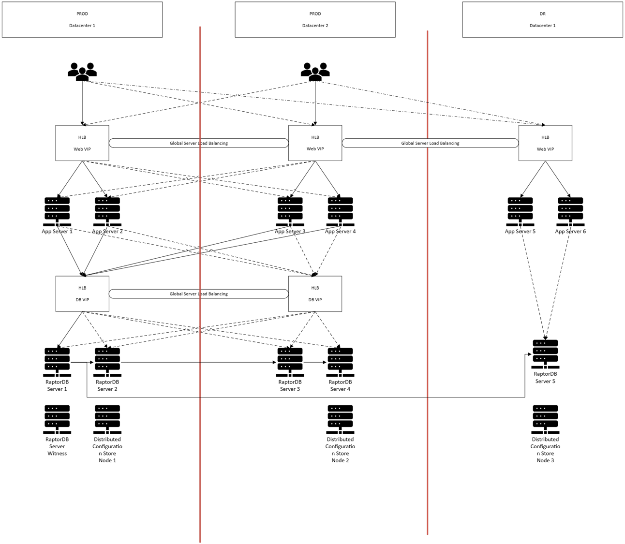

XXXXX
Included Services:

ASSUMPTIONS
This proposal assumes:
- Electric Boat maintains supported ServiceNow versions

PRICING
Pricing Structure:

PAYMENT TERMS
Invoicing. Everforth ECS shall invoice Unisys monthly in advance. Payment terms are net thirty (30) days from invoice date. Late payments shall accrue interest at the lesser of 1.5% per month or the maximum rate permitted by law.
Suspension for Non-Payment. Everforth ECS may suspend services upon ten (10) business days’ written notice for any invoiced amount more than thirty (30) days past due. SLAs shall be suspended during any period of non-payment. Such suspension shall not constitute a breach by Everforth ECS.
Annual Adjustment. If the engagement is extended beyond the initial twelve (12) month term, fees shall be subject to an annual adjustment equal to the greater of (i) three percent (3%) or (ii) the change in the U.S. Bureau of Labor Statistics Employment Cost Index for Information Sector workers for the trailing twelve months.
Taxes. Fees are exclusive of all applicable taxes other than taxes on Everforth ECS’s net income.

SUMMARY
This proposed support model is intended to provide enterprise-grade ServiceNow operational support services while appropriately recognizing the shared operational responsibilities among Electric Boat, Unisys, Everforth ECS, ServiceNow vendor support, and Electric Boat-controlled infrastructure and configuration teams.
This proposal is informational and is provided for discussion purposes only. It does not constitute an offer capable of acceptance and is expressly subject to the negotiation and execution of a mutually acceptable Statement of Work and Master Services Agreement. All terms herein, including pricing, are subject to revision until such definitive documentation is executed. In the event of any conflict between this proposal and the definitive documentation, the definitive documentation shall control.

